1.Configuration of Network Devices using Packet Tracer tools Hub.

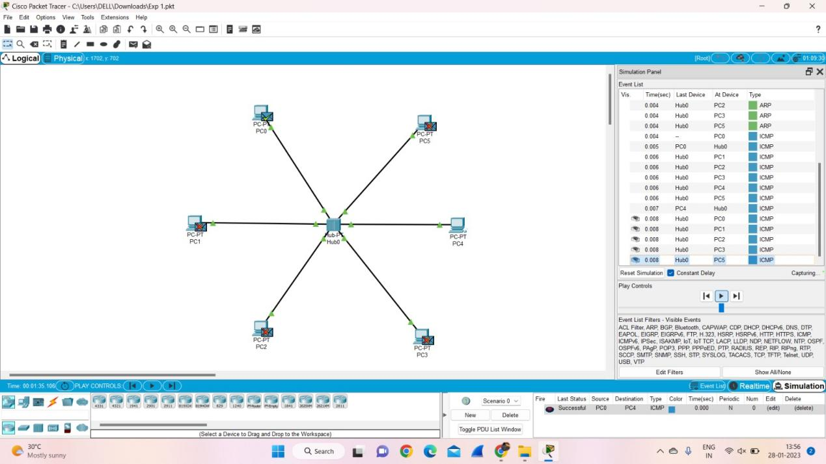

**2.**

Design and Configuration of Star Topologies using Packet Tracer

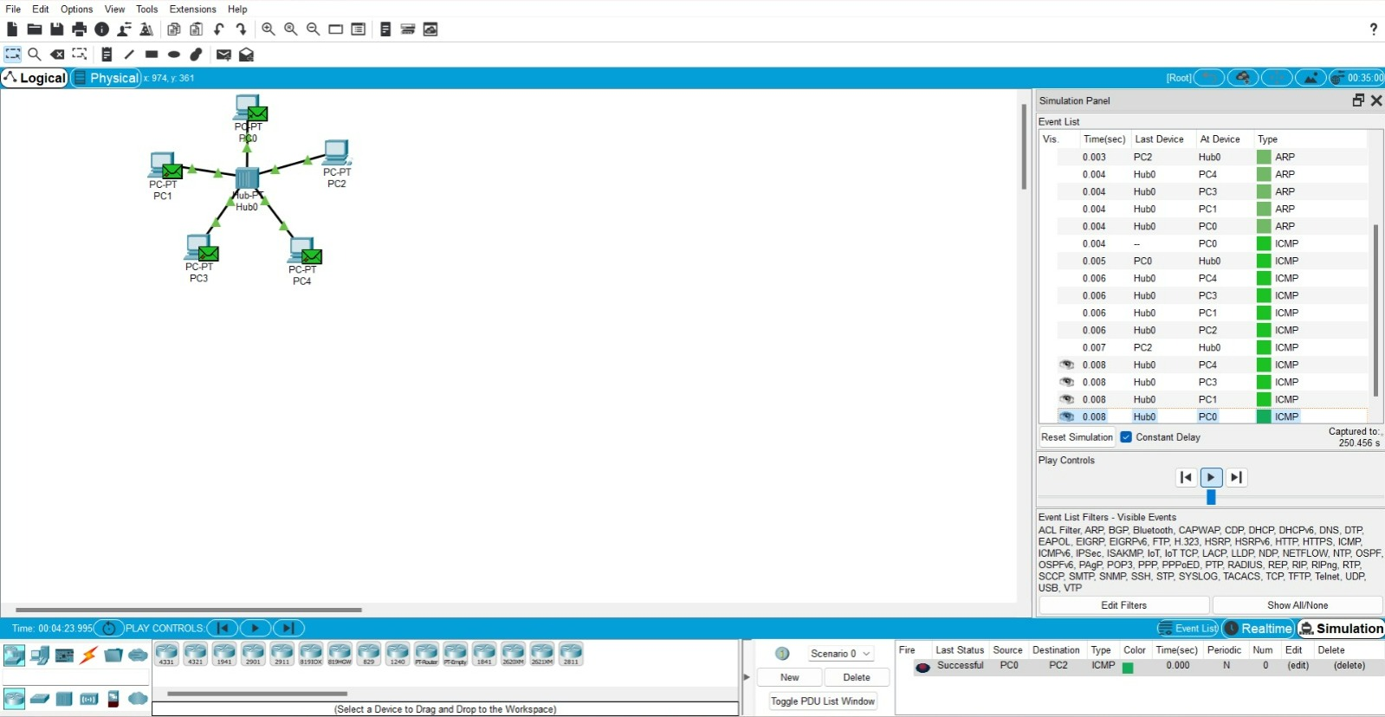

2.2

Design and Configuration of Mesh Topologies using Packet Tracer

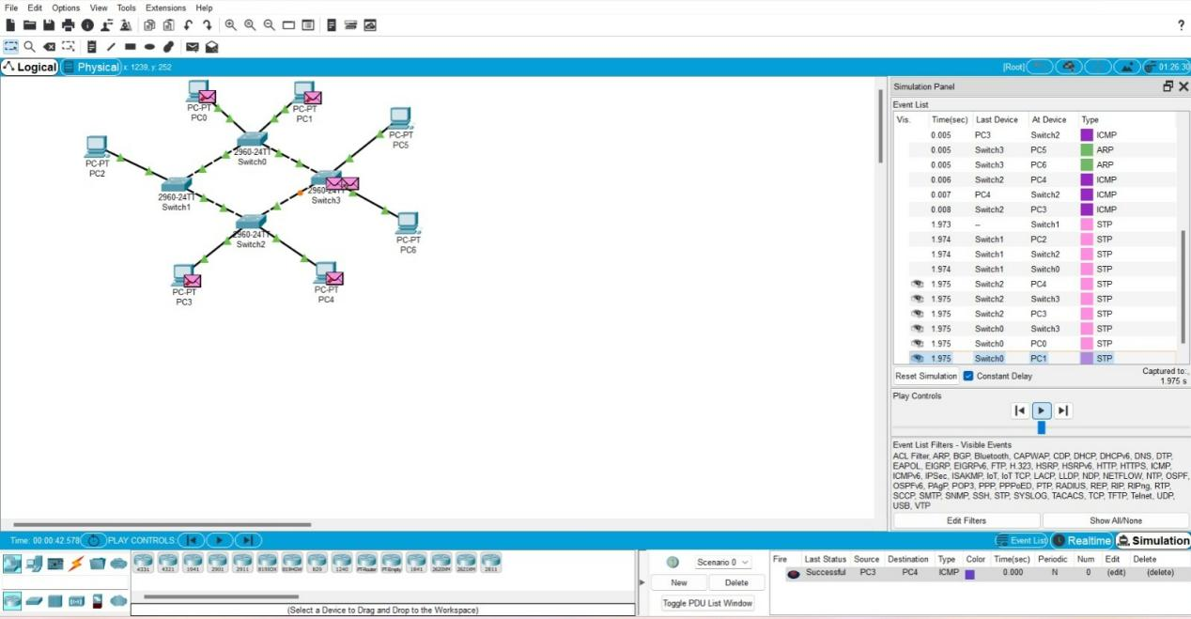

2.3

Design and Configuration of Tree Topologies using Packet Tracer

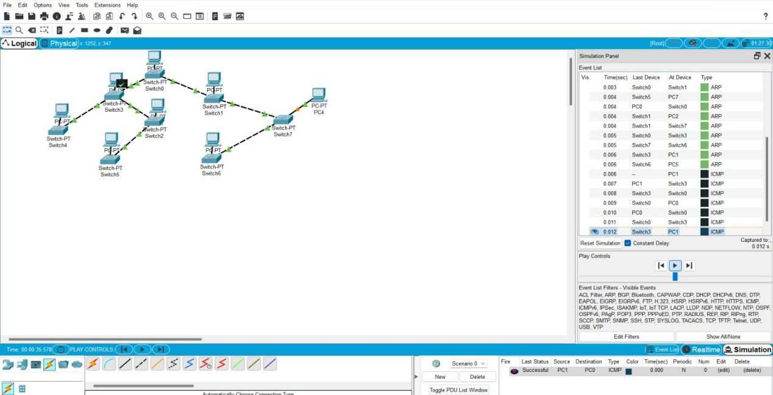

2.4

Design and Configuration of BUS Topologies using Packet Tracer

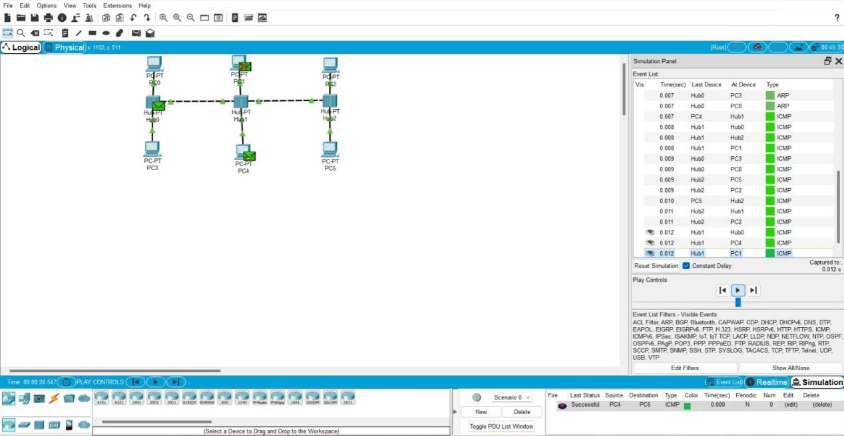

2.5

Design and Configuration of RING Topologies using Packet Tracer

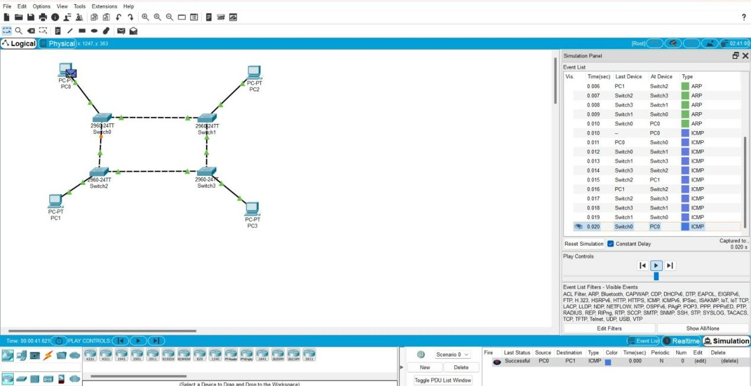

2.6

Design and Configuration of Hybrid Topologies using Packet Tracer

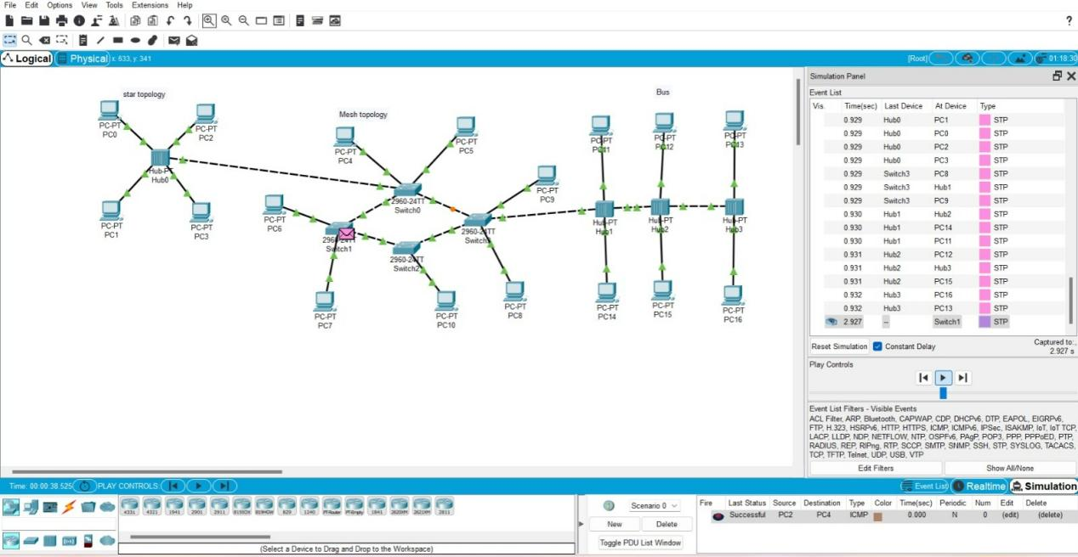

3

Data Link Layer Traffic Simulation using Packet Tracer Analysis

of CSMA/CD & CSMA/CA

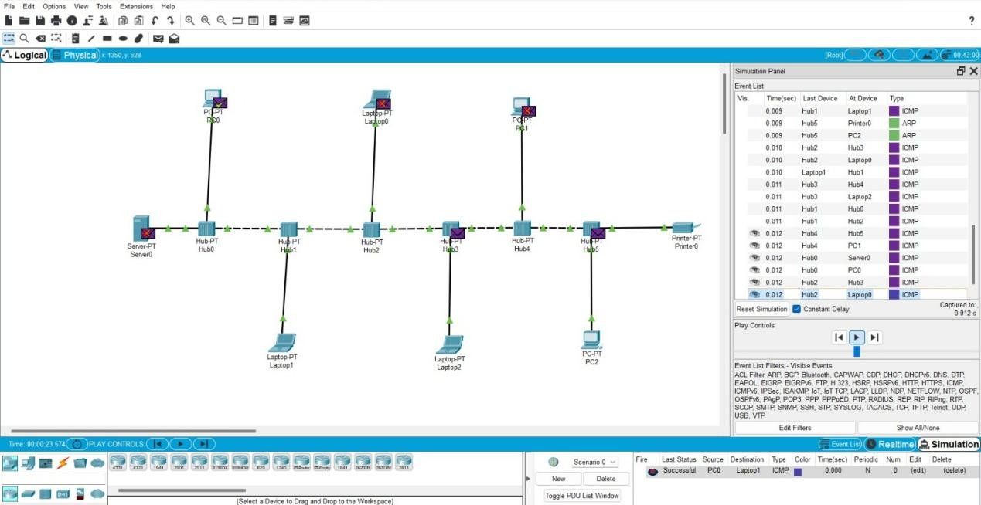

4.

Data Link Layer Traffic Simulation using Packet Tracer Analysis of

ARP

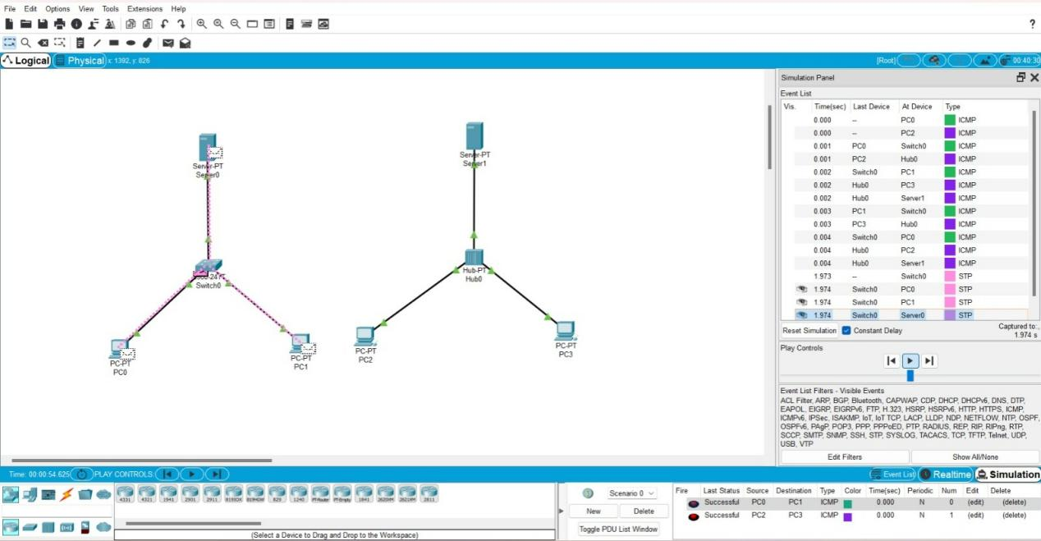

5

Data Link Layer Traffic Simulation using Packet Tracer Analysis of

LLDP

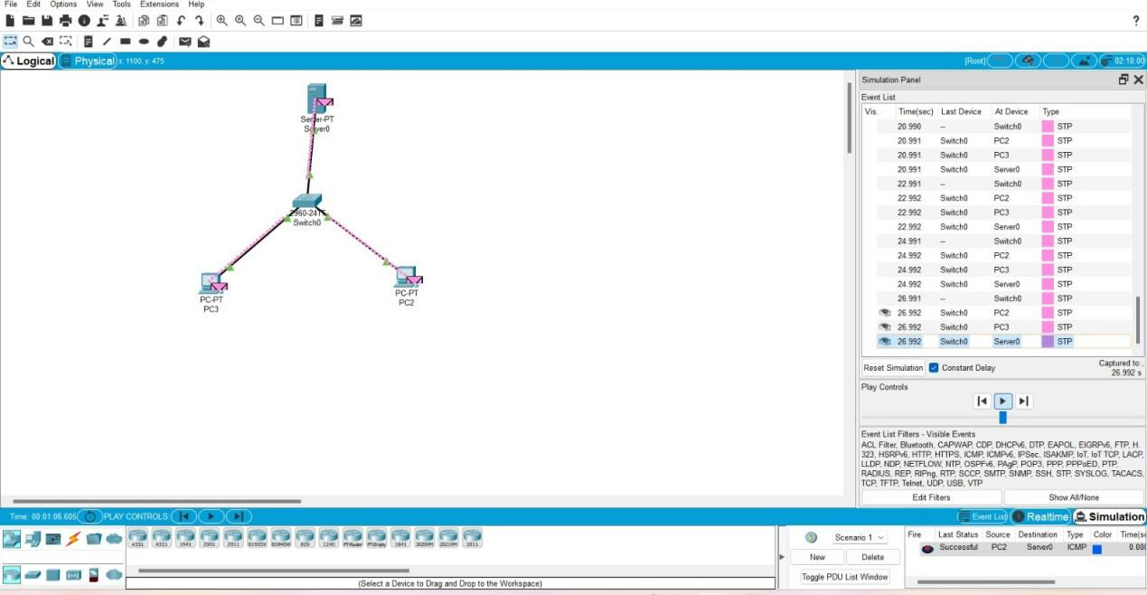

6

To design the two different network with Static Routing techniques using

Packet Tracer

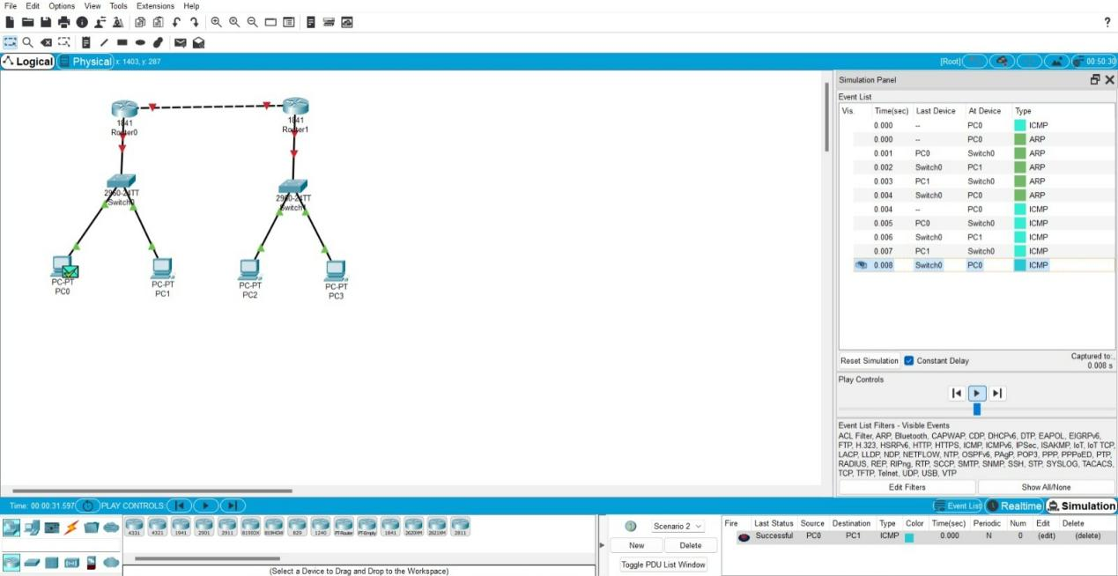

7

To design the Network with Dynamic Routing using Packet Tracer

(Distance vector & OSPF)

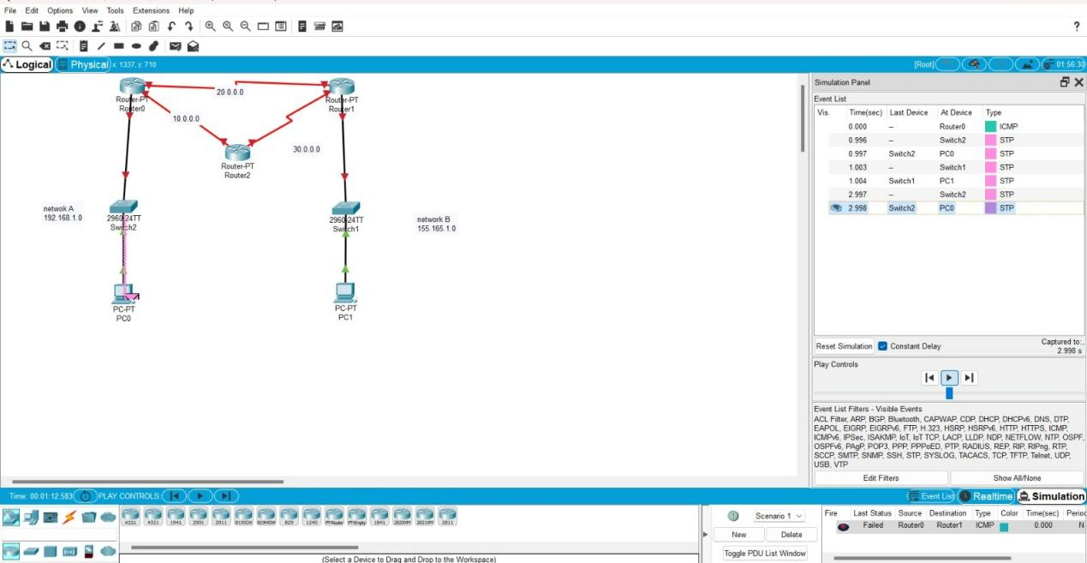

8

Design the network model for Subnetting – Class C Addressing using

packet tracer

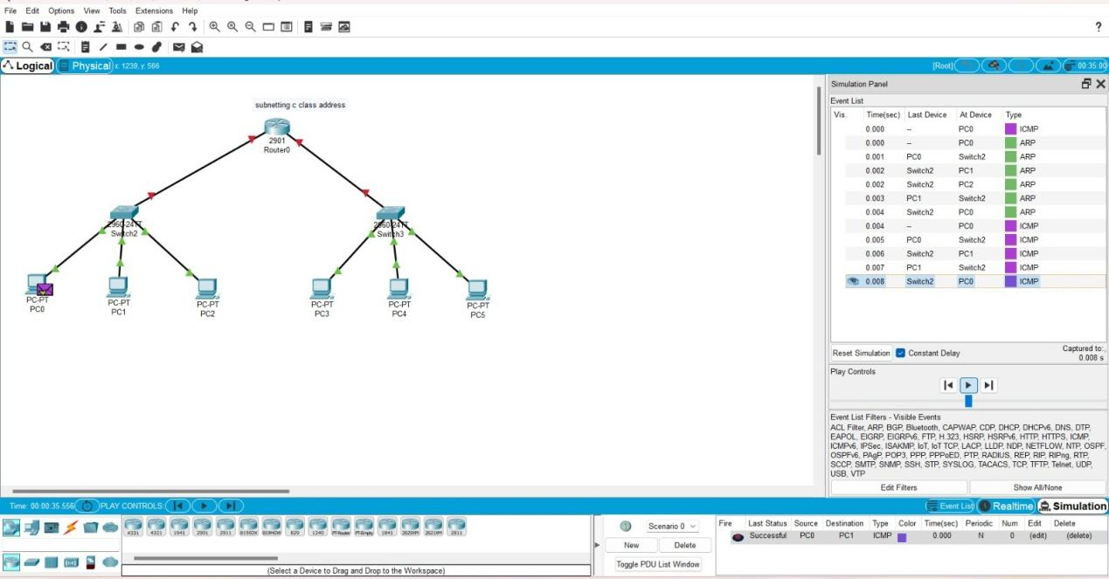

9

Design the Functionalities of TCP,UDP using Packet Tracer

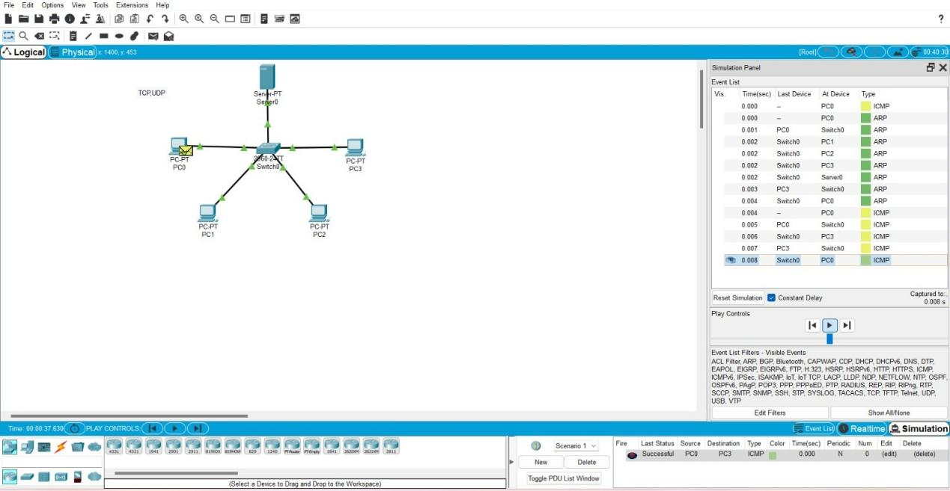

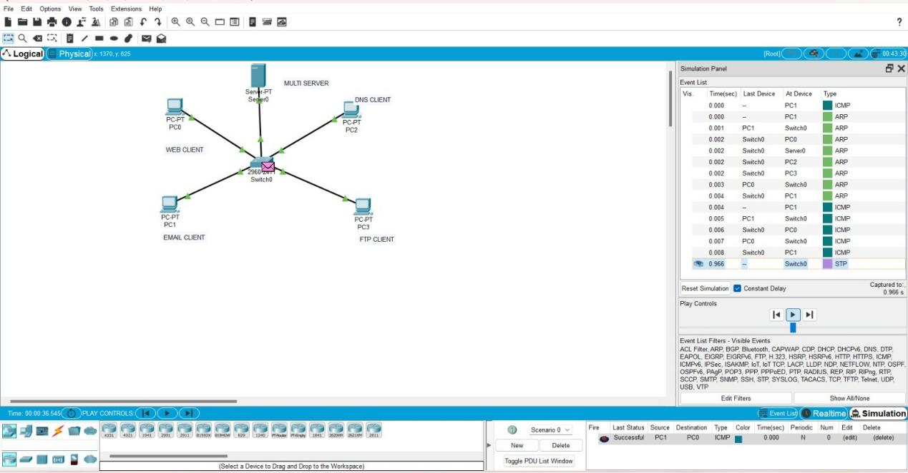

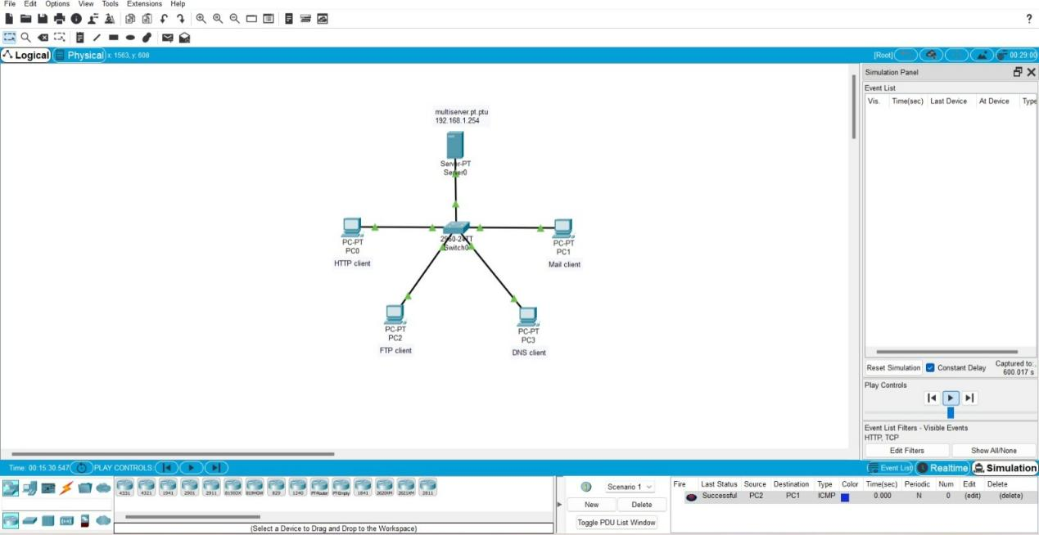

10

Design the Exploration Of TCP,UDP using Packet Tracer.

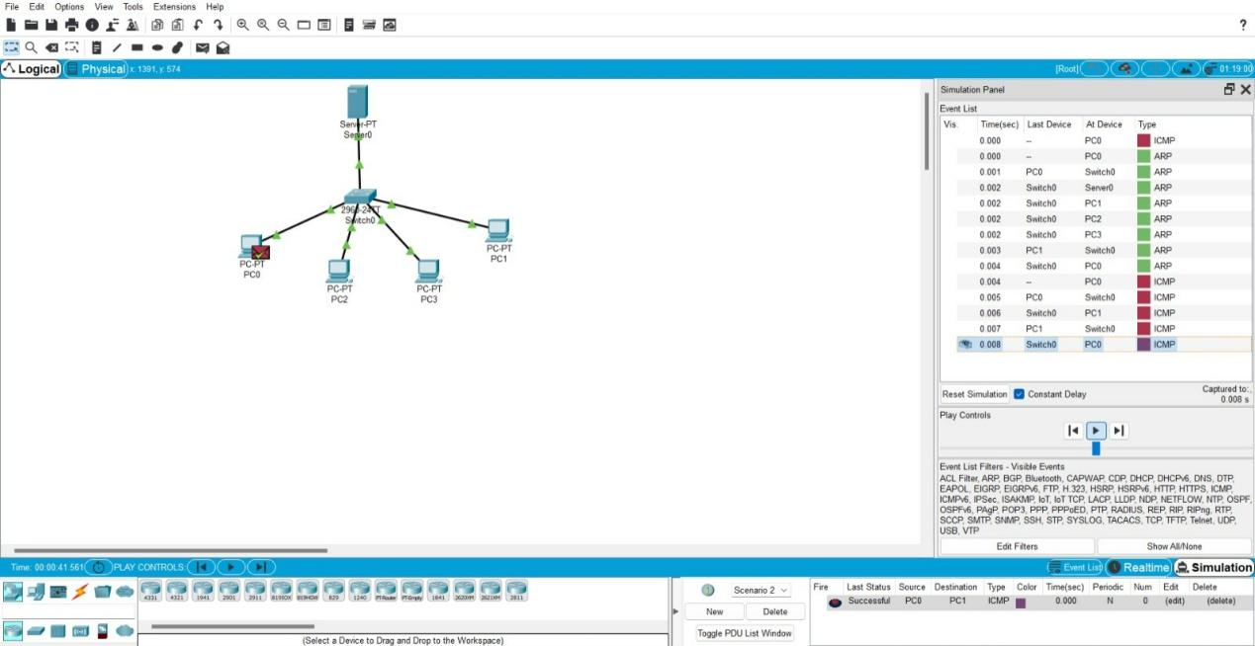

11.

IOT Based Smart Home using Cisco Packet Tracer.

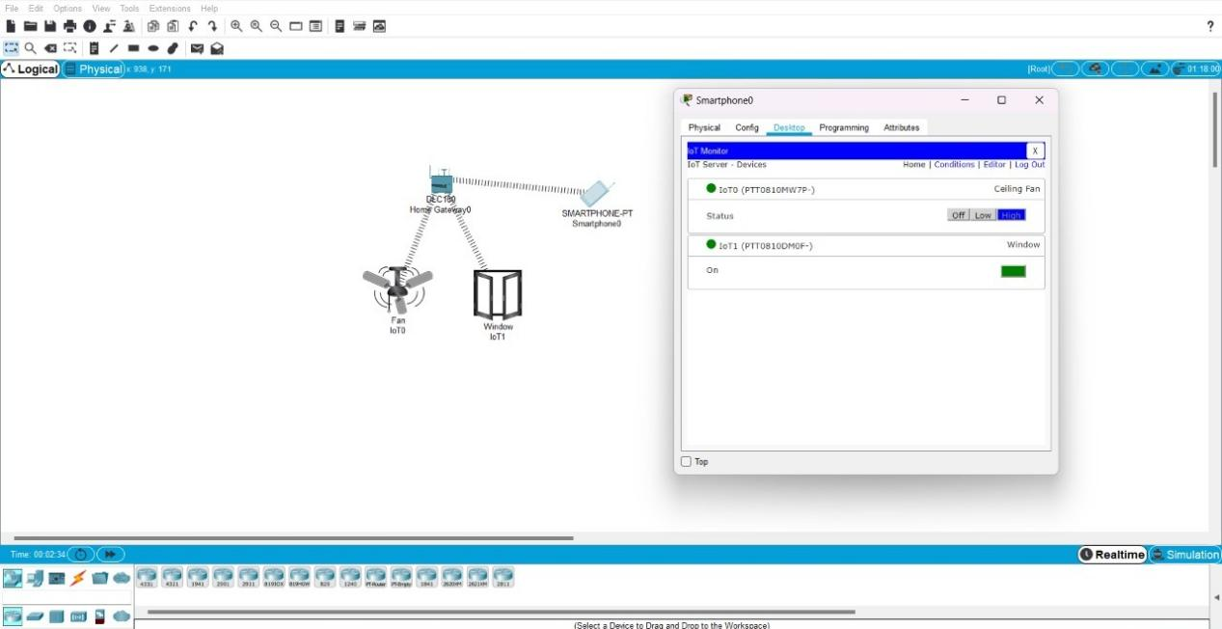

12.

Smart Garden in Cisco Packet Tracer.

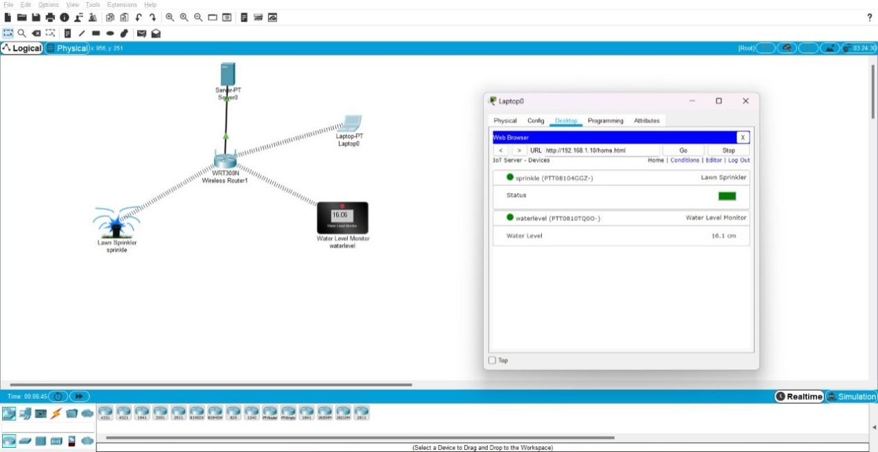

13.

IOT Devices in Networking Using Cisco Packet Tracer.

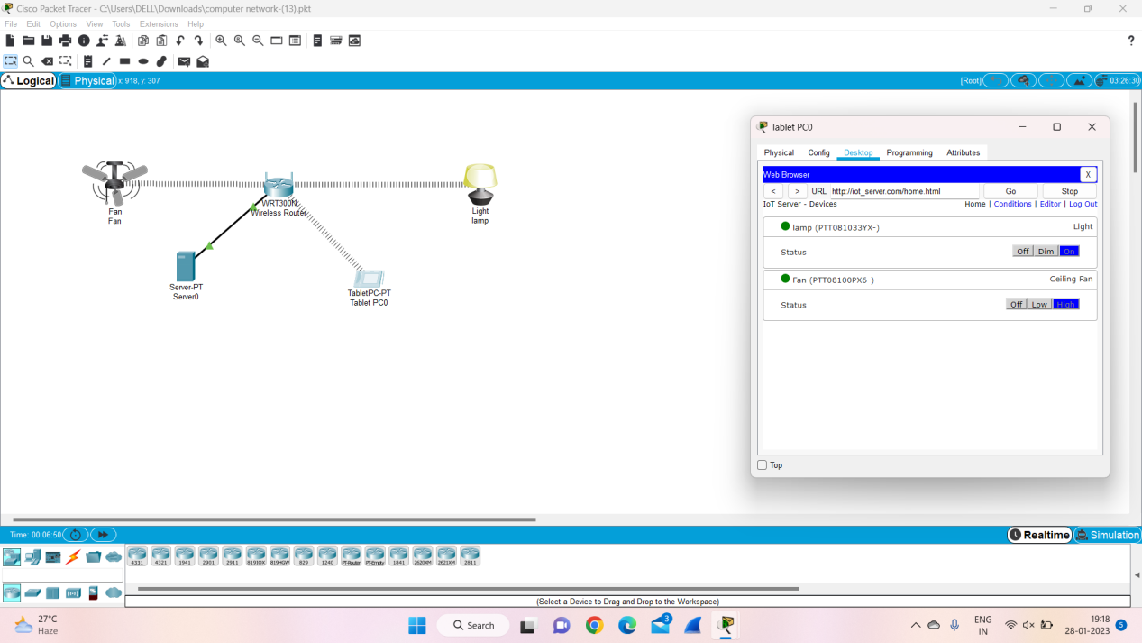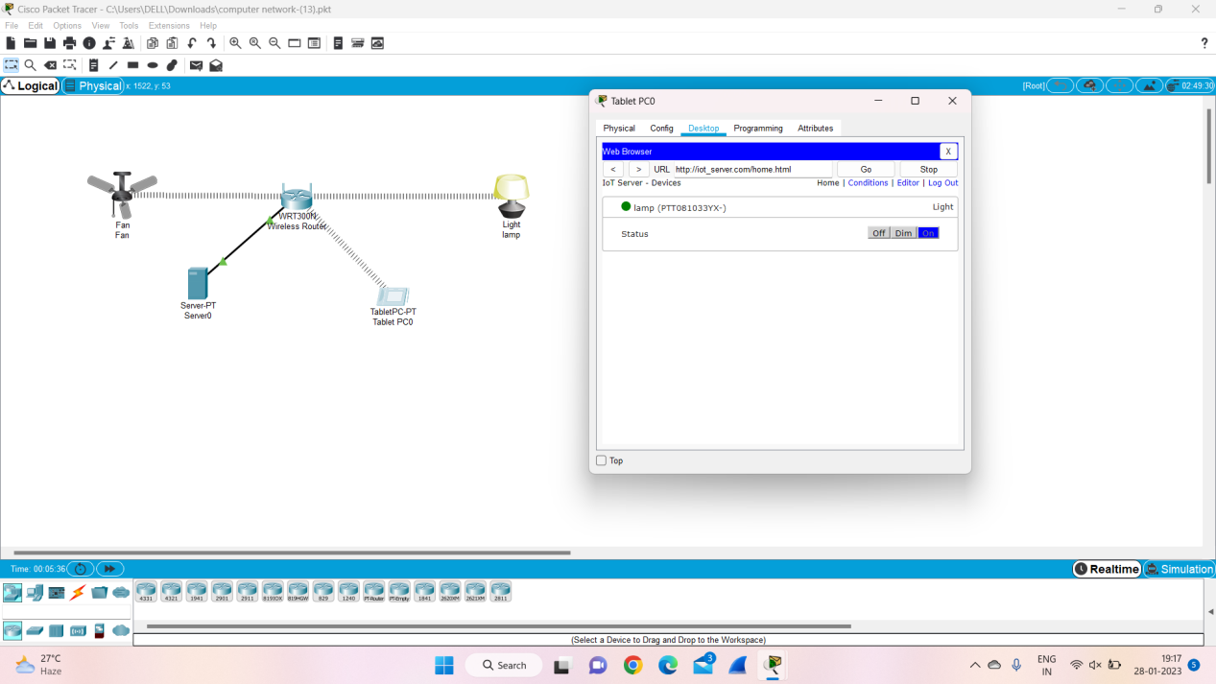

14.

Simulating X, Y, Z Company Network Design.

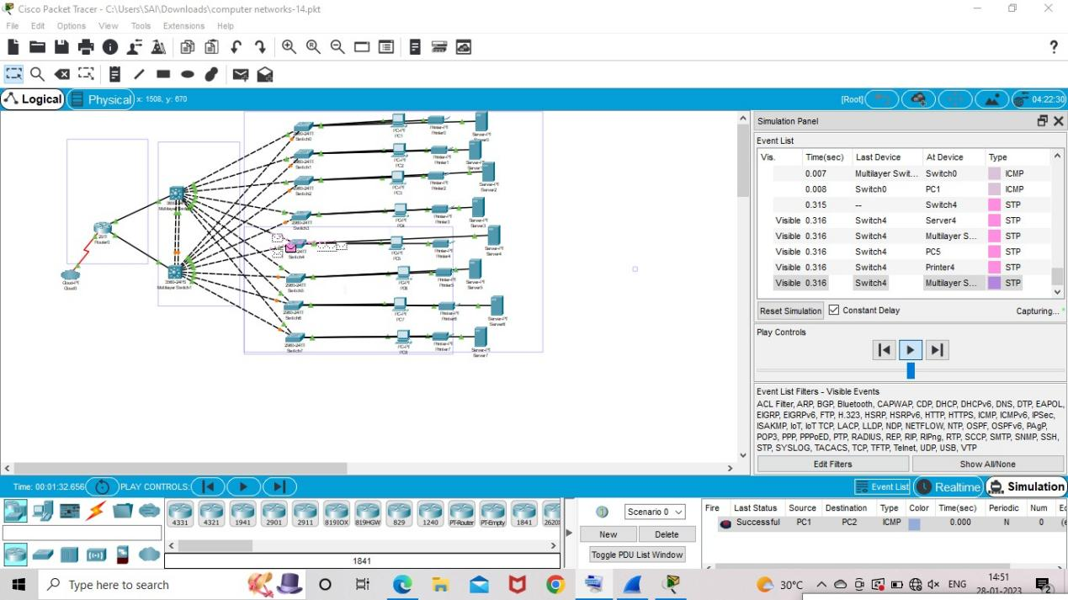

15.

Make Computer Lab in cisco Packet Tracer

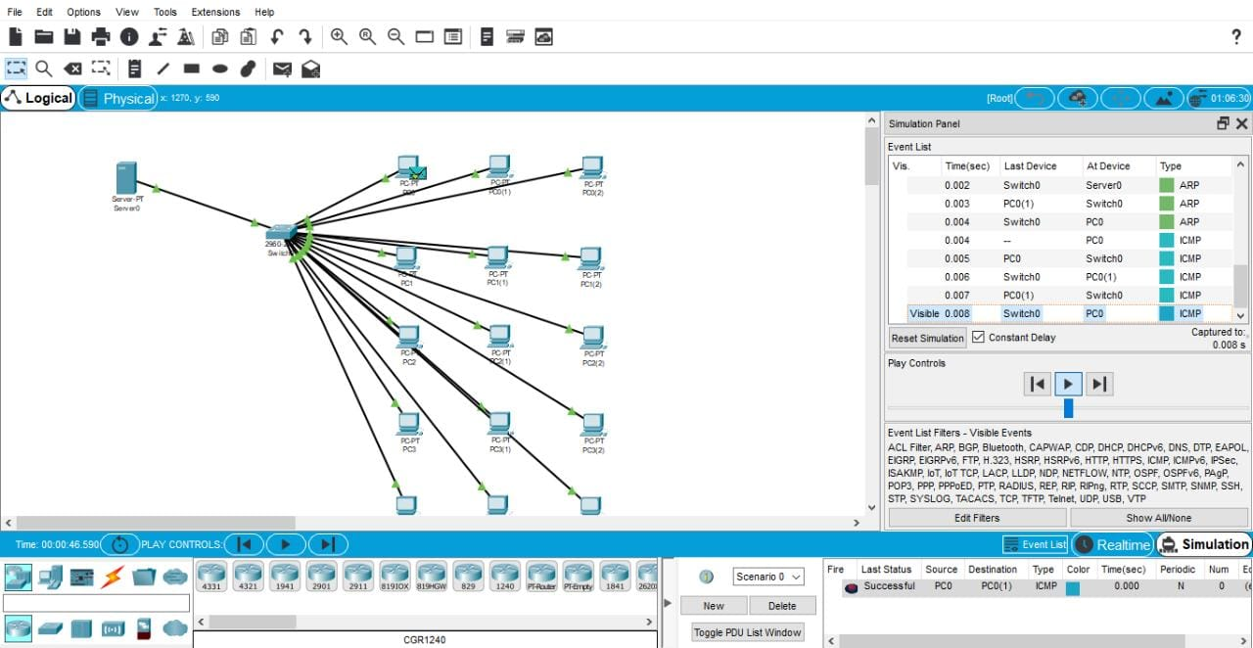

16.

Simulate a Multimedia Network

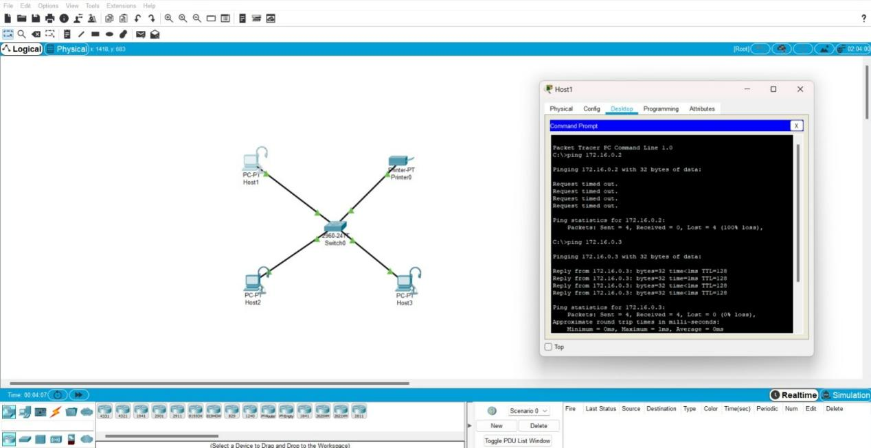

17.

AAA Local & Server Based Authentication Configuration in Cisco Packet Tracer

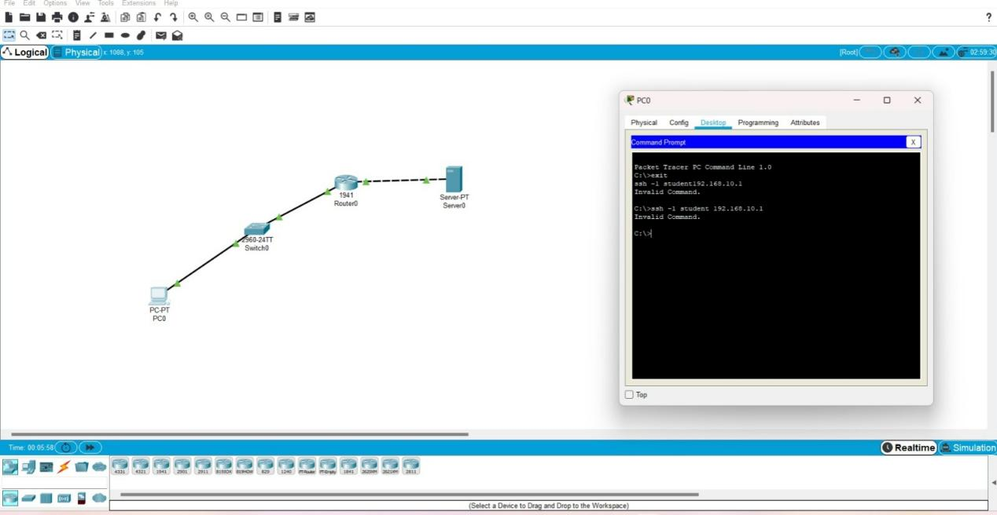

18.

IOT Based Smart Home using WPA Security & Radius Server.

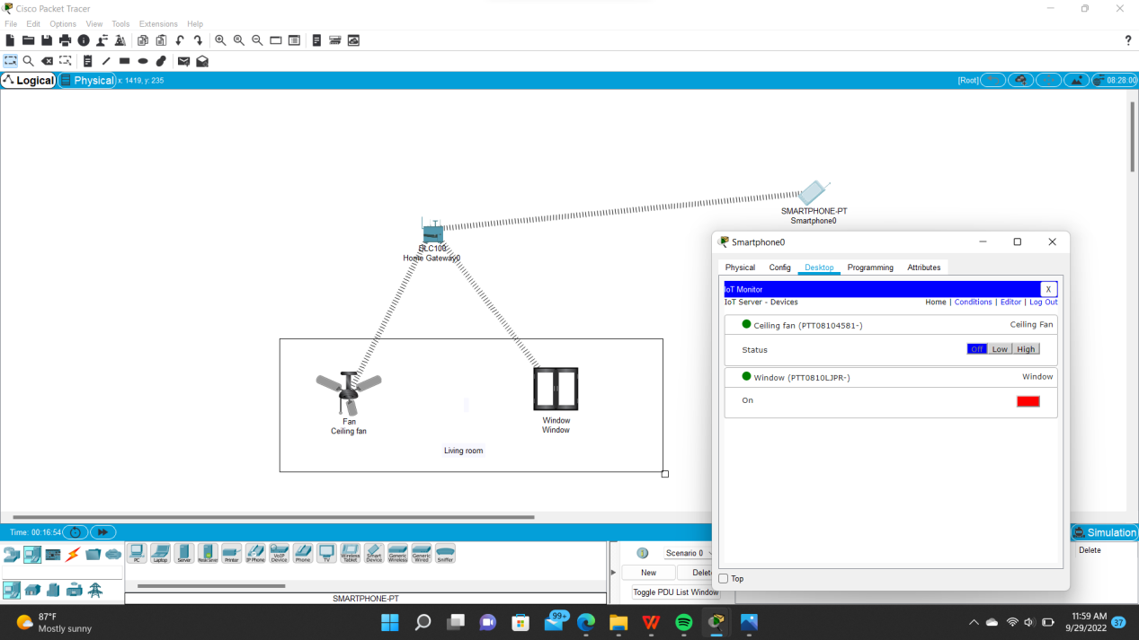

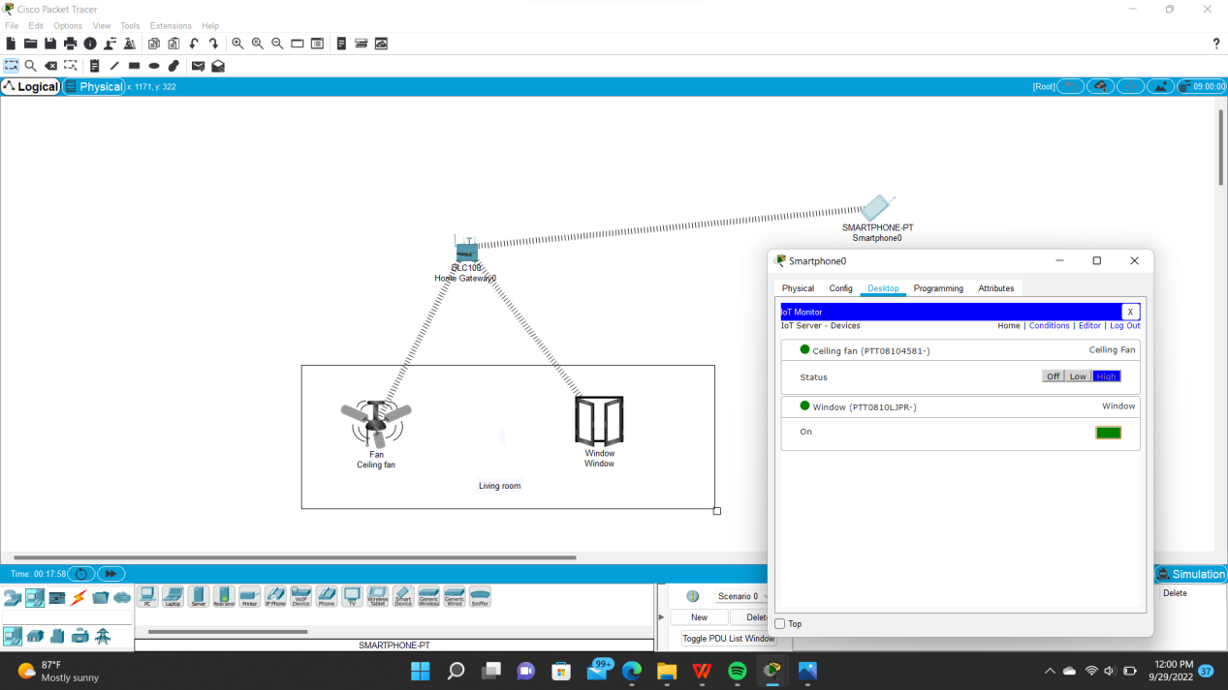

19.

WLAN Using Cisco Packet Tracer.

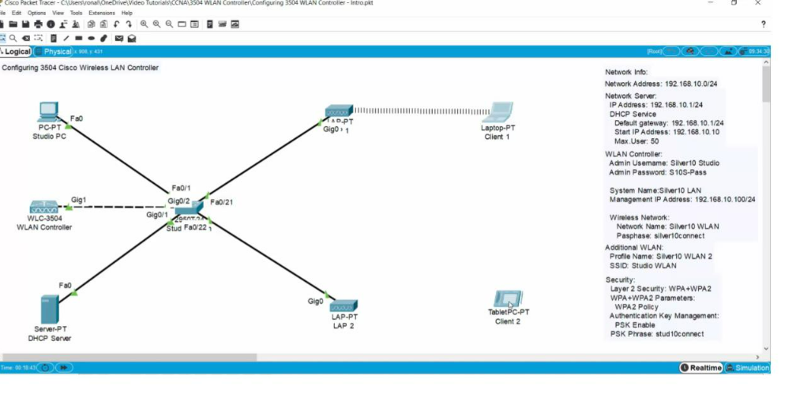

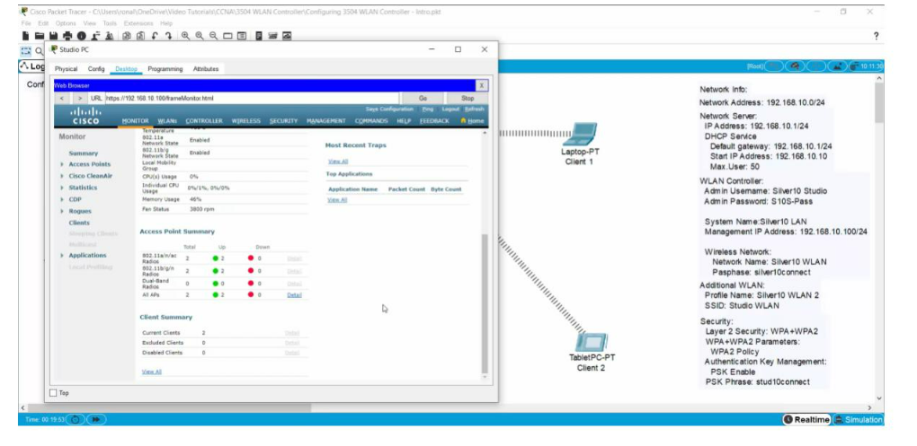

20.

Control of Fan,Light, Window & Application of Using Cisco Packet Tracer

